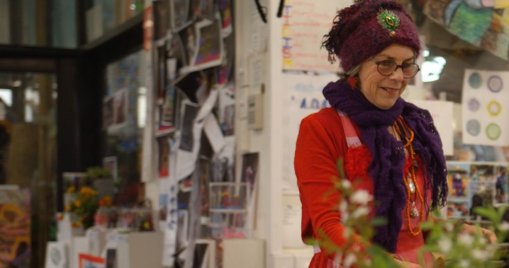
Video Discussion Guide:
Celebrating difference –
a conversation with Dee, a volunteer
Overview: Welcome to this heartwarming video - a beautiful chapter within our volunteers with disability awareness campaign. This initiative blossomed from a collaborative co-design project facilitated by the team at Volunteering Tasmania, bringing together stakeholders who shared a common goal. Our campaign is a beacon of hope, striving to nurture an inclusive and accessible volunteering sector. Together, let's make volunteering a source of joy and fulfillment for every individual.
Watch video here (5:20min)
Dee explains “the thing I find most supportive, particularly at the beginning of a new volunteering opportunity, is to feel understood, respected and listened to.”
What does your organisation do to help a new volunteer feel understood, respected and listened to?
One of the things Dee says that Interweave Art Studio does really well is that they “not only accept diversity, but they actually embrace and celebrate diversity.”
What are some of the things you do, or could do, in your organisation to really embrace and celebrate diversity, rather than just accept it?
Dee says “I am aware of my differences, but I celebrate my differences, and see that perhaps I can represent a different view in the workplace.”
What are some of the benefits that having a diverse workforce could bring to an organisation?
Dee says she had reached a point in her life where she would have been happy to be a virtual recluse, but instead, volunteering has led her to engage her community more than ever.
What benefits do you think Dee has gained from her volunteering, and what benefits has the community gained from her contributions?
Dee says her biggest challenge is “the fear inside me that I’m not good enough, that I’m not normal, that I won’t be acceptable.”
How do you feel when Dee says that? How does your organisation support volunteers to feel accepted?
Discussion points
- Volunteer diversity means diverse skills, experience and backgrounds.
There are many benefits for organisations when including people from diverse abilities, such as new ideas, new perspectives, and new ways of doing things.

- People with disability volunteer their time and skills in our community every day.
27% of the Tasmanian population have a disability, therefore in every organisation, workplace and community, people with disability make significant contributions.

- Volunteers with disability can be creative and innovative contributors.
Many innovations such as Braille and screen readers, were developed by people with disability out of necessity and now assist people all over the world, every day.

- Organisations are more dynamic and effective when they have greater diversity representation.
People with disability are often underrepresented at all levels, even in organisations who support people with disability.

- People are excluded by barriers in their environment and society, not by their impairment.
The social model of disability promotes an inclusive and equitable society which accommodates people with disability, rather than expecting a person to change to suit the environment.

- Volunteers with disability have a lot to offer an organisation.
Focus on the possibilities and the abilities rather than the disability. Don’t make assumptions about someone’s skills or capacity.

- There are many supports and resources available to support an organisation to engage a volunteer with disability.
Ask the person what they have found useful in the past. If they have a NDIS plan, consider what this may mean for their volunteering e.g. they may wish to have a support person with them.

www.volunteeringtas.org.au
We’d love to hear about your experience using this video and discussion guide – please send your feedback to team@volunteeringtas.org.au or call us on (03) 6231 5550.

Volunteering Tasmania gratefully appreciates the support of people with lived experience of disability and mental illness, along with the following organisations involved in the co-design project:
Australian Red Cross; Calvary Care; Disability Voices Tasmania; Inclusive Innovations Tasmania; Launceston Volunteers for Community; Mental Health Council of Tasmania; Mersey Community Care; National Disability Services; RSPCA; TasTAFE; and WISE Employment.

Our appreciation also goes to Interweave Art Studio for their support when filming this video and to The Human Story for producing such a wonderful video.

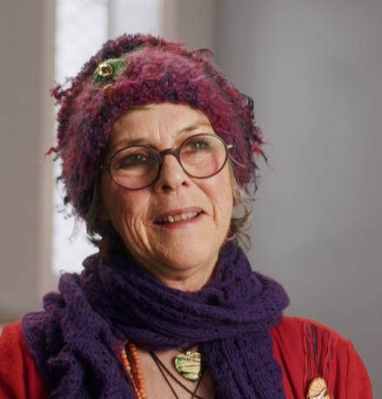
Many thanks to volunteer Dee Alford for sharing her story.
Dee lives artfully and mindfully in Northern Tasmania, contributing significantly to her community. She volunteers her time according to her values, to projects focused on art, inclusion, connection and all the benefits they bring.
Dee has supported many to engage with the positive impact of artistic exploration, including young people at school and in detention.
Dee is an artist and mentor at Interweave Arts Studio where she uses her people and art skills, with generosity and openness, to walk alongside people on their journey with art.
Dee is an active committee member of the Lilydale Progress Association which supports and promotes community health and wellbeing.
Dee has a lived experience with mental illness which she considers to be both a challenge and a resource in her life, giving her a unique perspective on how to value and engage with self and others.

Volunteering Tasmania acknowledges the palawa people as traditional custodians of the lands, seas,
skies, and waterways throughout lutruwita/Tasmania. We pay respect to elders past and present and
recognise their deep history and continuing connections with our shared country, culture, and community.

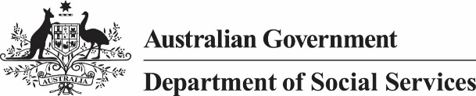
Funded by the Australian Government
Department of Social Services.
Visit www.dss.gov.au for more information.

